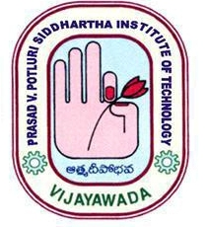
PVPSIT
Department of Mechanical Engineering
NEWS Letter

July – December, 2019

EDITORIAL BOARD

Chief Patron: Dr. K. Sivaji Babu

Chief Editor: Dr. B. RAGHU Kumar

Department Editor:
DR. Sd. Abdul Kalam

The Department of Mechanical Engineering has been in existence ever since the college started in year 1998. Department is affiliated to JNTU since 1998. B. Tech. Program is accredited by NBA-AICTE in May 2007 for 3 years and provisionally accredited for 2 years in June 2012 and is certified by ISO 9001:2008 certification. Once again it is provisionally accredited for 3 years under OBE in the year 2016 and got 4th time accreditation under OBE Tier-1 in 2019 for 3 academic years.

Numerous research papers have been published in National and International Journals and Conferences. The Department arranges guest lectures by eminent professors from India and abroad, scientists from research organizations and experts from industry to bridge the gap between academics and industry. Faculty members are encouraged to improve their academic qualification and to gain experience by attending FDPs, workshops, conferences etc. They are also encouraged to present research papers at workshops and conferences, and to participate in co-curricular and extracurricular activities.

The Department promotes active industry-institute collaboration by organizing workshops and by taking part in sponsored research projects and consultancy services. Visits to the industries for faculty and students are frequently arranged to enhance the practical exposure with the real corporate world. Department also organizes programmes like Alumni interaction sessions with current students and make them familiar with specific market requirements and demands.

Contents

- Guest Lectures / Workshops Organized

- Faculty Achievements

- Faculty Publications/ Conferences

- Workshops Attended by Faculty

- Industrial visits

- Students Achievements

- Workshops/Seminars/Guest Lectures/Training Programs/Symposiums organized:

- A Guest Lecture on “Application of Advanced Aerospace Materials” by Dr. K. Venkateswarlu, Senior Principal Scientist, NAL, Bangalore on 11.07.2019 for III B.Tech. students and the staff.
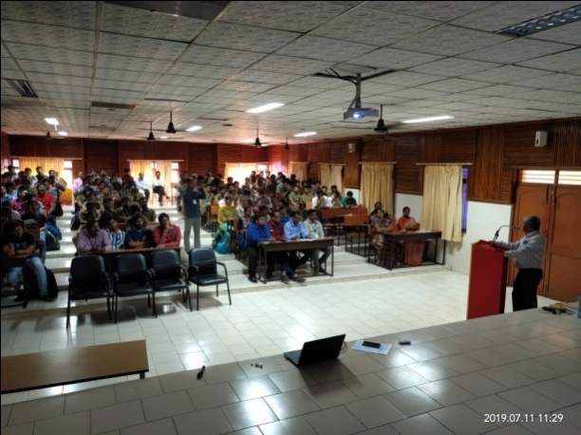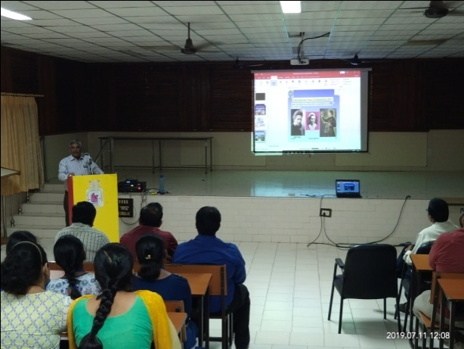
- A “Faculty Interaction Programme on Intellectual Solutions” by Dr. K. Venkateswarlu, Senior Principal Scientist, NAL, Bangalore on 11.07.2019 for the staff.
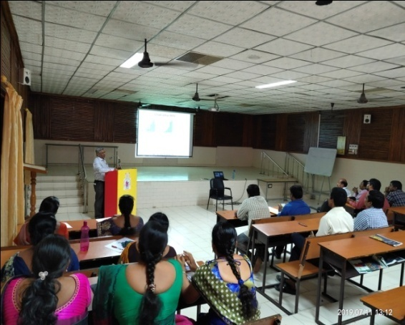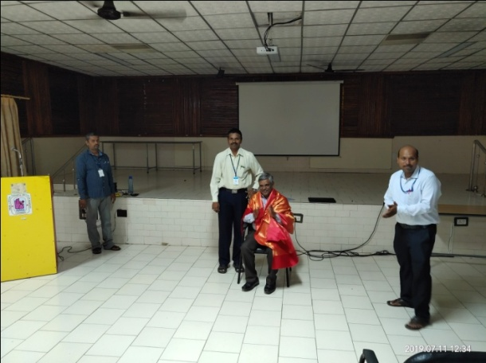
- A “Personality Development Programme” by Swami Mahakratu Dasa, ISKAN for II-B. Tech. ME students on 03.08.2019 in the Knowledge centre.

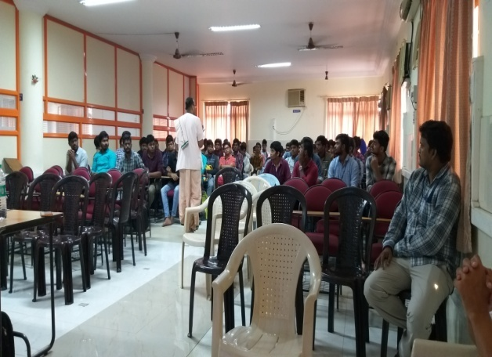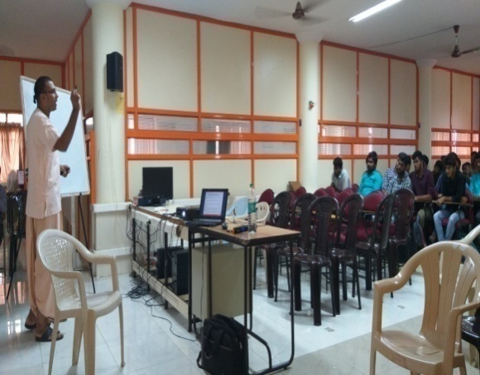
- An “Orientation Programme on NDT” by Sri. G. Vijay Kumar, CEO, Future NDT, Vijayawada for IV-B. Tech. M.E. students on 07.08.2019.

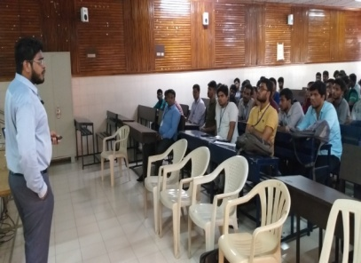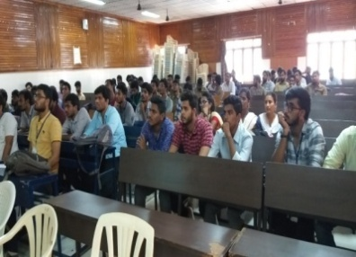
- An Awareness Programme on "Overseas Education” by Sri.K. Seshu Babu, Process Manager, Center for International admissions & VISAS (CIAV), Chandramouli Nagar, Guntur for IV-B. Tech. ME students on 12.09.2019.

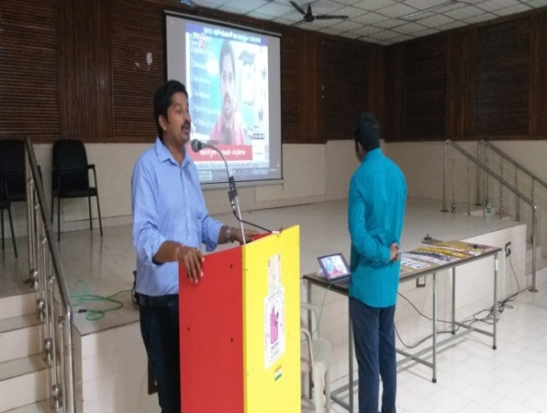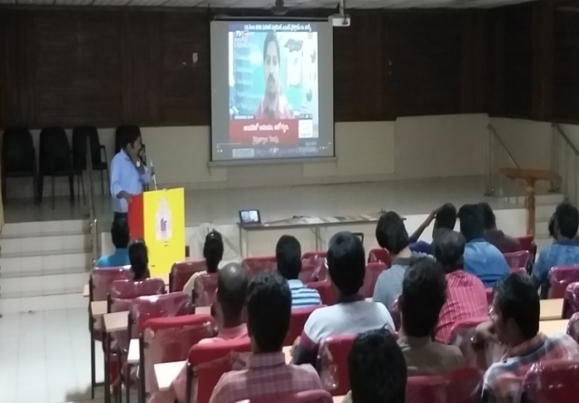
- A Two-week student training programme on “C& DS” by Mr. B. Sai Kiran, Trainer, BYTS, Hyderabad from 01.11.2019 to 16.11.2019 for III B. Tech. Mechanical Engineering students.

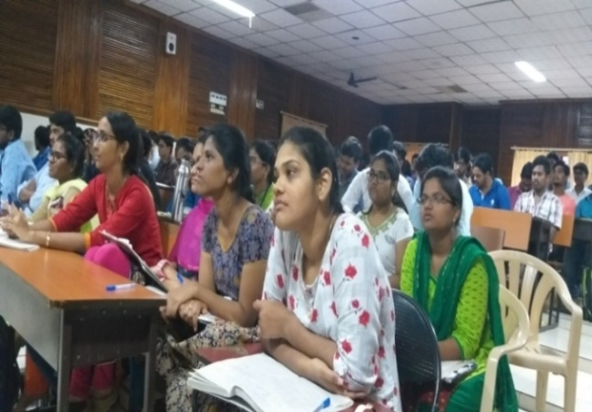
- An ICT based workshop on “Measurement Issues of Laboratories and workshop classes” by Dr. Dipankar Bose, Programme Co-ordinator and Resource Person, NITTTR, Kolkata from 04.11.2019 to 08.11.2019 for the Teaching and Non-teaching staff.

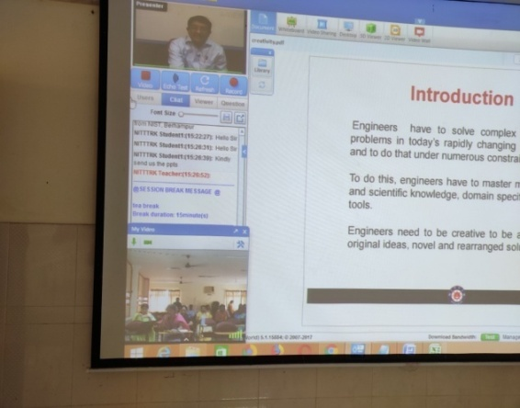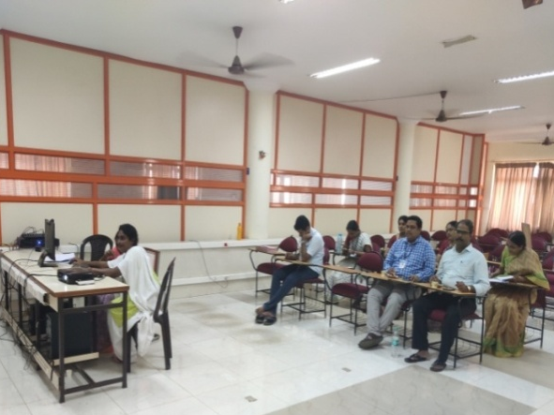

- A Guest Lecture on “Fluid Mechanics and Design of Mechanical Circulatory Support systems” by Dr. Prasad Patnaik B S V, Professor, Department of Applied Mechanics, IIT Madras, Chennai on 16.11.2019 for III & IV-B. Tech. Mechanical Engineering students and the staff.
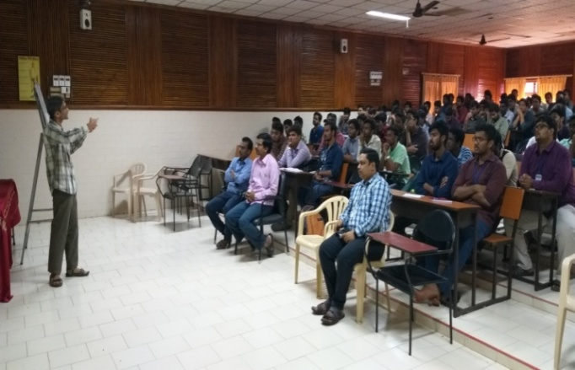

- An ICT based workshop on “Control and Automation” by Dr. Sagarika Pal, Program Coordinator and Resource Person, NITTTR, Kolkata from 18.11.2019 to 22.11.2019 for the staff at Knowledge Center, PVPSIT.
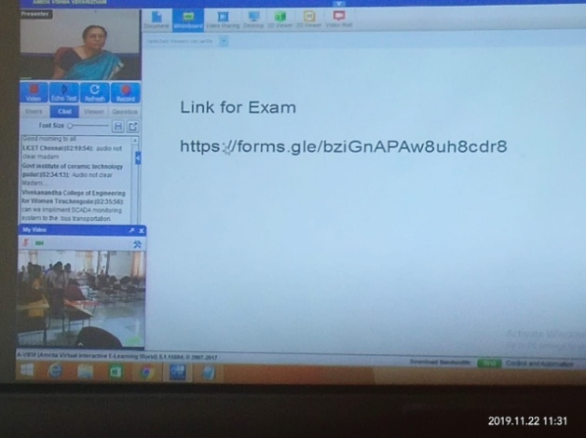

- A Guest Lecture on “Industry-4.0 in Manufacturing Engineering” by Dr. V. Vasu, Associate Professor, Department of Mechanical Engineering, NIT, Warangal on 22.11.2019 for II-B. Tech. Mechanical Engineering students and the staff.

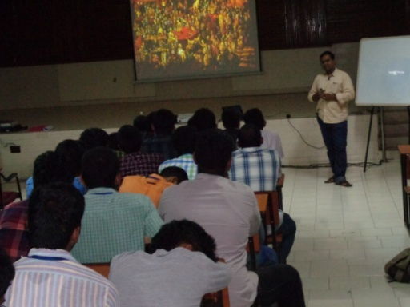
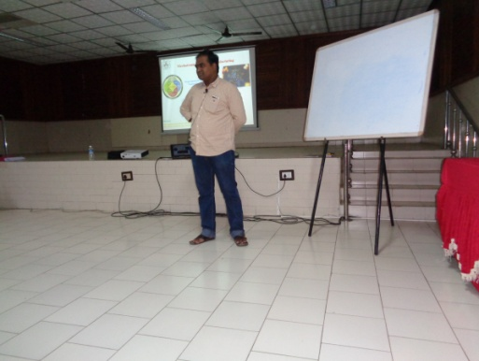

- A Guest Lecture on “Power Plant familiarization” by Sri. Rayavarapu Samuel Johnson, Assistant Divisional Engineer-Mechanical, Training Institute, APGENCO, Ibrahimpatnam, Krishna District, A.P. on 09.12.2019 for III-B. Tech. Mechanical Engineering students and the staff.
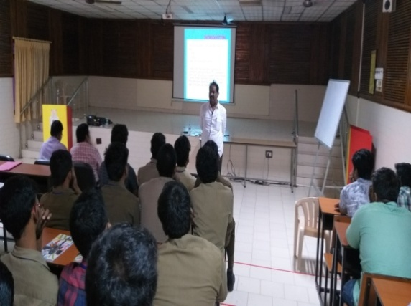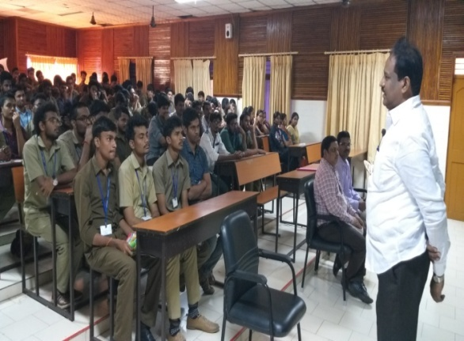

- A Guest Lecture on “Plastic product design and manufacturing” by Sri. V. Kiran Kumar, Director, Head & Quality Manager, Central Institute of Plastics Engineering and Technology (CIPET), Vijayawada on 16.12.2019 for II-B. Tech. Mechanical Engineering students and the staff.

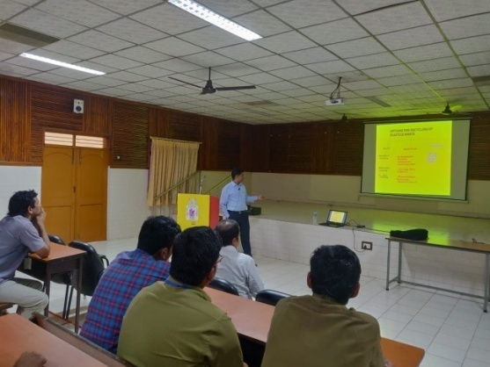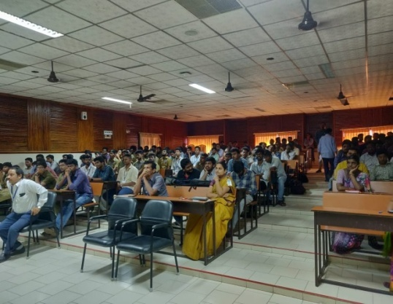

- Workshops/Seminars/Conferences/Faculty Development Programs attended by the
faculty:

- K.Venkat Rao participated in a seminar on “Disruptive Technologies, Innovation and New Product Development” at Chanakya Seminar Hall (ESCI), Gachibowli, Hyderabad on 12th July, 2019.
- G.Bala Krishna participated in a one-week Global Initiative of Academic Networks (GIAN) course on “Medical Prototyping using 3D Printing” at NIT,Warangal from 15th -19th July, 2019.
- Dr.G.Vijay Kumar participated in the National Workshop on “Research Integrity & Awareness” organized by University Grants Commission (UGC), South Eastern Regional Office, at University of Hyderabad, Gachibowli, Hyderabad on 5th August, 2019.
- U.Koteswara Rao participated in the Applied Robotics Control Lab Faculty Development Program:2.0 under the initiative of Indo European Skillling Cluster for Mechatronics and Manufacturing by European Centre for Mechatronics,Aachen/Germany and Andhra Pradesh State Skill Development Corporation, AP,India and successfully executed the assigned industry project tasks and related software implementation at VIT-AP,Amaravathi,indiaconducted by German Center for Advanced Engineering and Management Studies UG and APS GmbH-European Center of Mechatronics from 5th – 12th August,2019.
- K.Sriram Vikas, and Ch.Kishore Reddy participated in a Five-Day Workshop on “Hands on Practice-Writing Technical Research Articles and Reports” at NIT, Warangal from 7th -11th August, 2019.
- The faculty attended an Expert Talk on “Developing Learning Outcomes” by Dr. N.Siva Prasad, Pro-Vice Chancellor, GITAM University, Hyderabad conducted by PVPSIT on 24.10.2019.

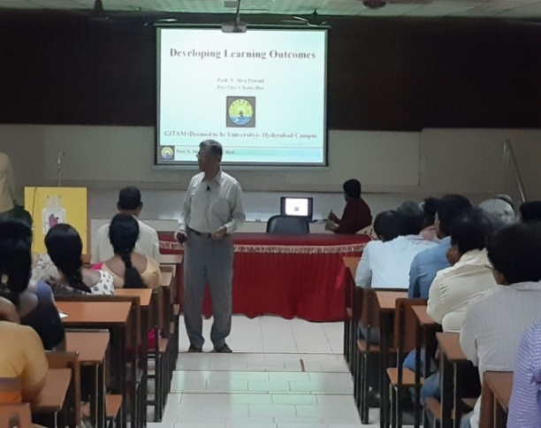
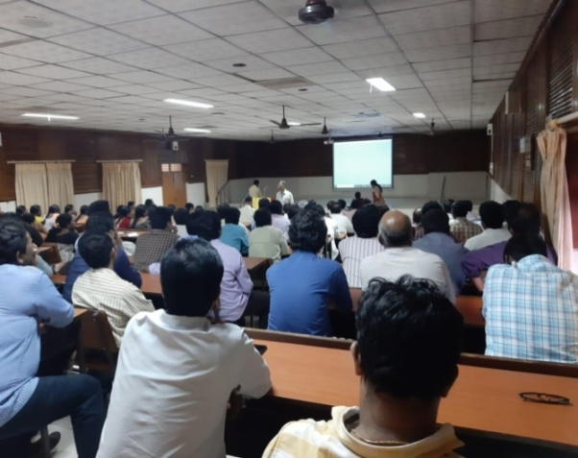

- Dr.B.Raghu Kumar participated in a One-day Workshop on “NIRF Ranking” organized by Andhra Pradesh State Council of Higher Education on 17th October, 2019.
- P.Anusha participated in an AICTE sponsored Faculty Development Programme on
“Emerging Technologies and Challenges in Mechanical Engineering” at R.V.R & J.C
College of Engineering, Guntur from 21st Oct – 2nd Nov, 2019.
- P.Anusha, and Dr.M. Naga Swapna Sri participated in an AICTE Sponsored Short
Term Course on “Advances in Thermofluidics of Multiphase Flows” at IIT Madras from
4th to 9th November, 2019.
- T.J.Prasanna Kumar, and K.Venkat Rao participated in an AICTE Sponsored Short
Term Course on “ Advanced Computational Techniques for Fluid Dynamics:Grid free
and immersed Boundary Methods with Apllications at IIT Madras from 25th to 30th
November, 2019.
- Dr. G.Vijay Kumar, and Dr. Ravi Prakash Babu participated in a One-week AICTE Training and Learning (ATAL) Academy Programme on “3D Printing and Design”(course code:AGHY0040) at National Institute of Technology, Warangal from 16th to 20th December, 2019.
- Dr.K.Srividya, and E. Kavitha participated in a One-week GIAN course on “Mechatronics Systems and Product Design” (Course code:171036L01) at National Institute of Technology Warangal from 16th to 20th December, 2019.
- Publications by the faculty (National/International Journals/ Conferences):
International Journals:

Scopus indexed:
- Arun Babu, B. Raghu Kumar, P.Phani Prasanthi, A. Eswar Kumar, and Ch. Vidya pubished a paper on “Fatigue Characterization Of Sisal Fiber Reinforced Composites Using Experimental And Finite Element Method” in International Journal of Innovative Technology and Exploring Engineering (IJITEE) ISSN: 2278-3075, Volume-8 Issue-10, August, 2019.
- Snigdha Surapaneni, P.Phani Prasanthi, M. Mounika, A. Eswar, and K.Venkata Rao pubished a paper on "Fracture Behavior Of Nano Particle Reinforced Sisal Fiber Composites Using Analytical And Experimental Methods" in International Journal of Innovative Technology and Exploring Engineering (IJITEE) ISSN: 2278-3075, Volume-8 Issue-10, August, 2019.
- K. Ravi Prakash Babu, B. Raghu Kumar, G. Durga Prasad, and V. Mohan Manoj published a paper titled, “Estimation of Reduced Stiffness under the Influence of Crack in a Beam, in International Journal of Innovative Technology and Exploring Engineering (IJITEE), Volume-9 Issue-1, November, 2019.
- G Vijay Kumar, and M V Ramesh published a paper titled, “Design and Fabrication of Solar Powered Autonomous Seed Sowing Vehicle”, in International Journal of Innovative Technology and Exploring Engineering (IJITEE) ISSN: 2278-3075, Volume-9 Issue-1, November, 2019.
- B. Raghu Kumar, and Abhijeet H. Kekan published a paper titled, ‘Natural Frequency Response Of Rotor Shaft To Crack Depth And Crack Location’, in International Journal of Mechanical and Production Engineering Research and Development (IJMPERD), Vol. 9, Issue 6, 499–510, December, 2019.
- K. Sivaji Babu, M. S. R. Niranjan Kumar P. Phani Prasanthi, and A. Eswar Kumar, published a paper titled, ‘Analysis of Sisal Fiber Waviness Effect on the Elastic Properties of Natural Composites Using Analytical and Experimental Methods’ in Journal of Natural Fibers, Volume-14, Issue-, December 2019.
- Non - Scopus indexed:
- G Dilli Babu, D Siva Sankar, and K Sivaji Babu pubished a paper on "Experiment on Optimization of Robot Welding Process Parameters" in International Journal of Recent Technology and Engineering ISSN: 2277-3878, Vol 8, Issue -4, July, 2019.
- P. Sai Kumar, M.S.R. Niranjan Kumar, and P. Gopala Krishnaiah pubished a paper on "Optimization of Process Parameters of Wire Cut Electrical Discharge Machining on Titanium Grade-5 Material using Design of Experiments" in International Journal of Innovative Technology and Exploring Engineering (IJITEE) ISSN: 2278-3075, Volume-8 Issue-11, September, 2019.
- K. Srividya, P. Anusha, E. Kavitha, and M. Nagaswapnasri pubished a paper on "Fabrication of Silicon Carbide and Graphite Reinforced Aluminium MMC by Stir Casting and Characterization by Wear Test" in International Journal of Innovative Technology and Exploring Engineering (IJITEE) ISSN: 2278-3075, Volume-8 Issue-11, September, 2019
International Conferences

- G Dilli Babu, B Jagadish Babu, and K Sivaji Babu pubished a paper on "Experimental Investigation on Surface Roughness of Turned Nano- Khorasan Based Pineapple Leaf fibre- Reinforced polymer Composites using response surface methodology" in International conference on Materials and Manufacturing Methods, July 5-7, 2019.

- Faculty Achievements (Higher Qualification awarded, guest lectures given,
awards and rewards, acted as a Judge or Resource person etc.):
- Mrs. M. Nagaswapna Sri , Assistant Professor was awarded Ph. D. degree in September, 2019.

- Dr.B.Raghu Kumar acted as a Judge in the 14th National Level Technical and Cultural Fest for Technical Paper Presentation at Lakki Reddy Bali Reddy College of Engineering on 21st December, 2019.

- Industrial Visits:
For III B. Tech. students:
S.No | Year of Study | Name of the Industry Visited | Date(s) of visit
1 | III(section-2) B.Tech I semester | CIPET | 23-07-2019
2 | III(section-1) B.Tech I semester | CIPET | 24-07-2019

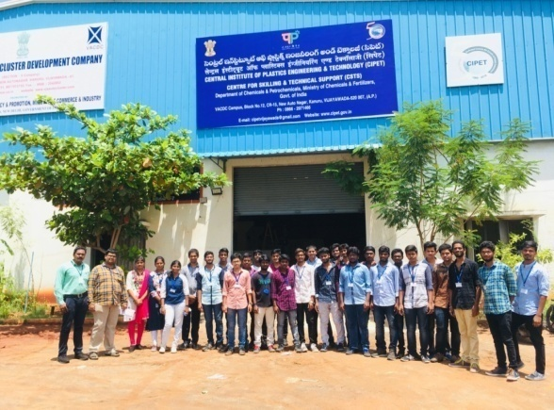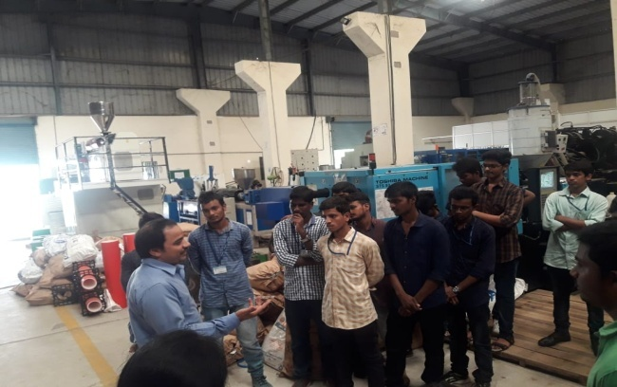

For II B. Tech students:
S.No | Year of Study | Name of the Industry Visited | Date(s) of visit
1 | II(section-2) B.Tech I semester | Kristna Engg Works | 25-09-2019
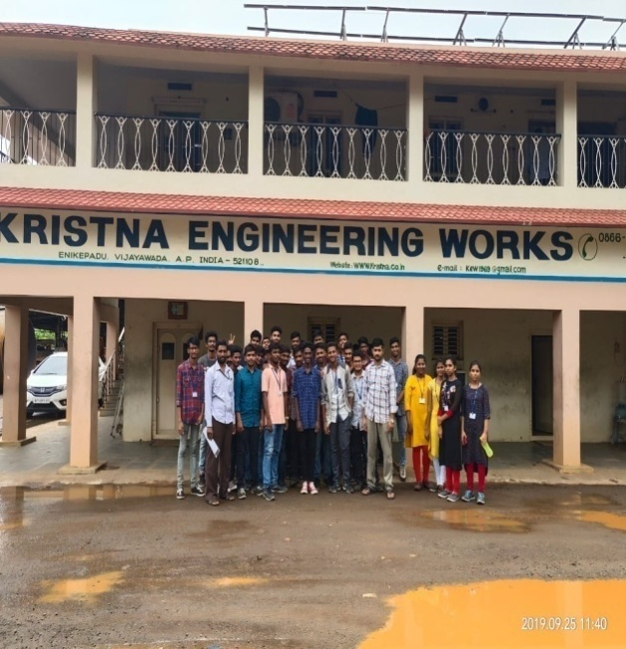 |  | 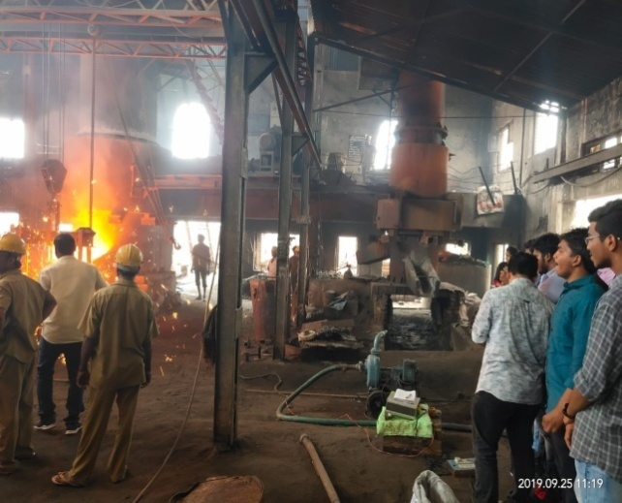
- II-B .Tech. Section-1 students visited G.S. Alloy Castings, Surampalli, Vijayawada on 24.12.2019.
- II-B. Tech Section-2 students visited G.S. Alloy Castings, Surampalli, Vijayawada on 28.12.2019.
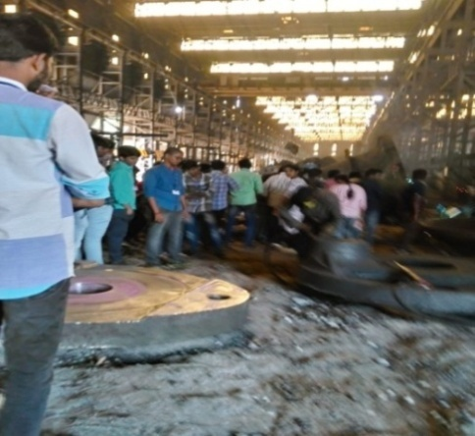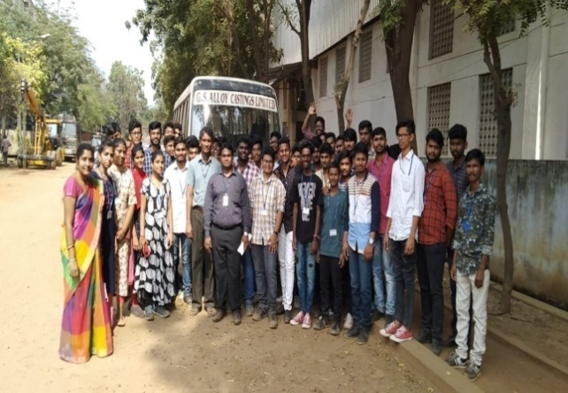

- MOUs Signed:

  - An MOU with Annoor Envirochem and Food Analytical Laboratory, An NABL Accredited Laboratory.
  - MOU With Neeraj Industries Vijayawada has been renewed for 5 years.
  - MOU's of GS alloys and Kristna Industries has been renewed for five years .
  - A MOU is signed with MEDINI for 4 years.
  - Drs Sudha & Nageswara Rao Siddhartha Institute of Technology of Dental Sciences, Gannavaram.
  - Smt Velagapudi Durgamba Siddhartha Law College, Vijayawada.
  - KVSR Siddhartha College of Pharmaceutical Sciences, Vijayawada.
  - Sree Vahini Institute of Science and Technology, Rajupeta.
  - Andhra Loyola Institute of Engineering and Technology, Vijayawada.
  - RK College of Engineering, Kethanakonda.
  - DMS SVH College of Engineering, Machilipatnam.
  - MoU's of CIPET has been renewed for five years.

- Students' achievements:
    - Literary and Cultural Activities/Academic awards:
  - M.Vikas Das,K.Sai Sankaran,M.Sri Naga Sai Harsha of II B.Tech. participated and received an award for exceptional contribution as 2nd Runner –Up in “Smart India Hackathon,2019”(Hardware Edition) at NIT, Tiruchirapalli from 8th -12th July, 2019.

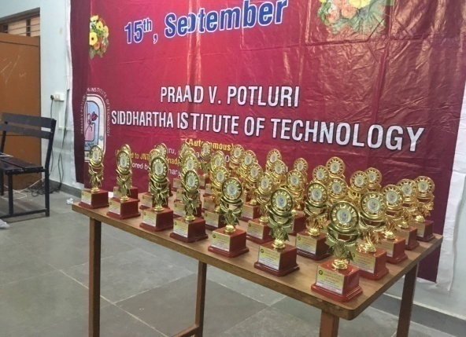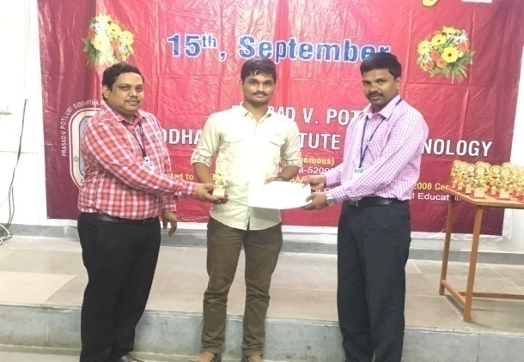
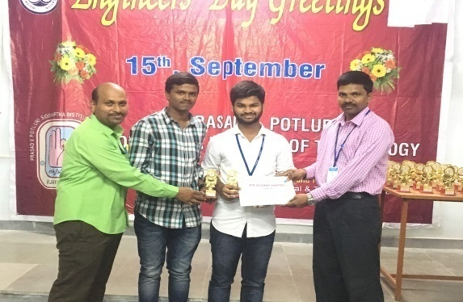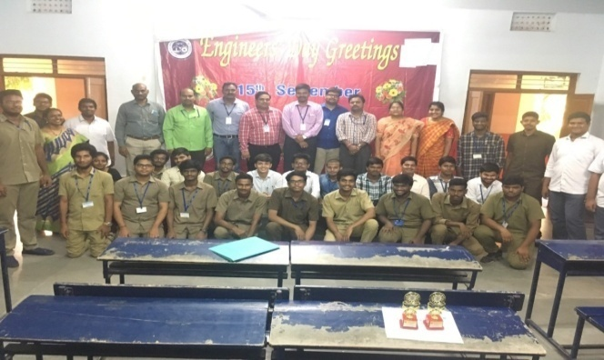
\

b) Presentation/Participation in Seminars/Conferences/Workshops:
- Md.Salman of III B.Tech has participated in the seminar on “Disruptive Technologies, Innovation and New Product Development” at Chanakya Seminar Hall(ESCI), Gachibowli, Hyderabad from 12.07.2019.
- VRSS.Sumanth, and V.Sailesh of IV B.Tech actively participated in the Young Scientist’s Conference as a part of India International Science Festival-2019 and presented a paper on the theme Make in India titled, “Design and Fabrication of Fixed Wing Unmanned Aerial Vehicle” at science city, Kolkata from 5th to 8th November, 2019.
- D. Tarun, and L. Sai Uma Mahesh of IV B.Tech participated in the India International Science Festival, 2019 for the event Mega Science, Technology & Industry Expo at science city, Kolkata from 5th to 8th November, 2019.
- A.Aaron Amrith, K.Sai Dikshit, Md.Sameer, and K.Dheemanth of I B.Tech participated in the 59th Gora Science Exhibition and presented a model on “Line Following Robot(ROVER)” and secured I Grade at Gora Science Centre, Vijayawada on 4th and 5th December, 2019.
- G.R G.Raja Mouli, K.Kamal, B.Adithya, and K.Rohit of I B.Tech participated in the 59th Gora Science Exhibition and presented a model on “Fire Rescue Drone(FRD)” and secured II Grade at Gora Science Centre, Vijayawada on 4th and 5th December, 2019.
- G.Jaswanth, K.Mani Naga Kumar, B.Tarun Kumar, and Md.Abdul Rahim Ahmed of I B.Tech participated in the 59th Gora Science Exhibition and presented a model on “Amphbious Robot(Dual Robot)” and secured II Grade at Gora Science Centre,Vijayawada on 4th and 5th December, 2019.
- A. Naga Ravi Teja of III B.Tech. participated in the event Screwit and won 1st prize at VIVA VVIT 2019-20 at Venkatadri Institute of Technology, Nambur on 21st December, 2019.
- Ch.V.S.S/Vivek of II B.Tech participated in the event Screw it and won 1st prize at VIVA VVIT 2019-20 at Venkatadri Institute of Technology, Nambur on 21st December, 2019.
- P.Hemanth Gowd of III B.Tech. participated in the event Paper Plane of Lakshya 2k19 and won the 1st prize at Lakireddy Balireddy College of Engineering, Mylavaram on 21st December, 2019.
- P.Hemanth of III B.Tech participated in the event Water Rocketry of Lakshya 2k19 and won the 2nd prize at Lakireddy Balireddy College of Engineering, Mylavaram on 21st December, 2019.
- A.Naga Ravi Teja of III B.Tech participated in the event Identification of parts and won the 2nd prize at VIVA VVIT 2019-20 at Venkatadri Institute of Technology, Nambur on 22nd December, 2019.
- Ch.V.S.S/Vivek of II B.Tech participated in the event Identification of parts and won the 2nd prize at VIVA VVIT 2019-20 at Venkatadri Institute of Technology, Nambur on 22nd December, 2019.
- Others:
Ongoing Minor Projects Sanctioned By UGC:
S.No | Funding Agency | Name of the research project | Amount Sanctioned | Suctioned Year | Faculty
1 | UGC | Virtual repair of Engineering structures using piezoelectric materials | Rs. 3,50,000/- | 2014 | Mr. Koteswara rao Unnam
1 | UGC | Development Of Nano Silver And Nano Copper Reinforced Low Density Polyethylene Antimicrobial Bottles | Rs. 3,00,000/- | 2016 | Dr. K.Sivaji Babu
2 | UGC | Agro Waste Based Nano Composites | Rs. 2,65,000/- | 2016 | M. Mounika

- Alumni information:
- Mr.G Sri Naga Sai (12501A0325) who is working as Assistant Manager in Grameena Bank, Karnataka II interacted with II B.Tech Sec-1students and delivered a talk on Career orientation talk (opportunities in Banking Sector).
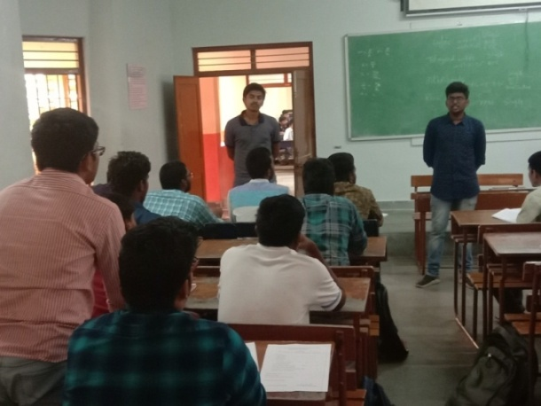
- Mr. Mr.Koundinya NTBN (06501A0305) who is doing Post Doctorial Fellow at IIT Madras interacted with II B.Tech Sec-2 students and delivered a talk on Future studies in Reputed institutes (opportunities in IIT’s).
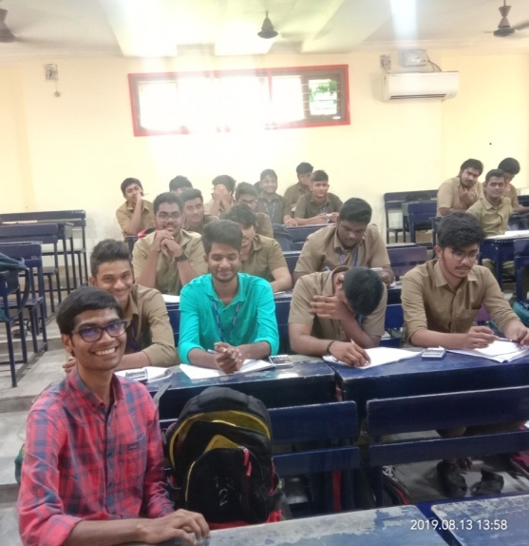
- Mr.Seethepalli Sreeharsha (13501A0394) who is working as Senior Mechanical Engineer in L & T New Delhi interacted with II B.Tech Sec-1students and delivered a talk on Career orientation talk (opportunities in core branches).
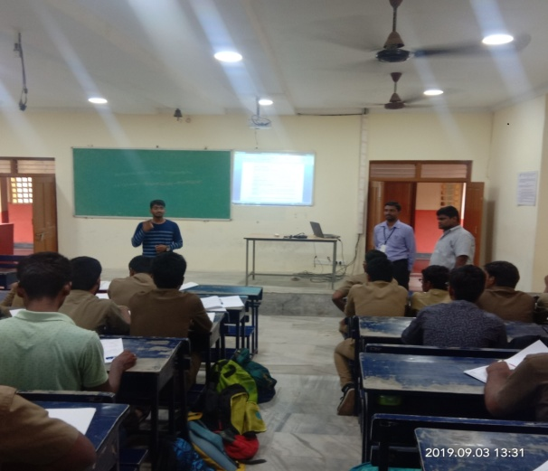
- Mr.Karri Samadhanam (16505A0311) who is working Indian Institute of Engineering
Science and Technology, Shibpur interacted with II-B.Tech I Sem S-1 students on Higher
studies in IIT’s.

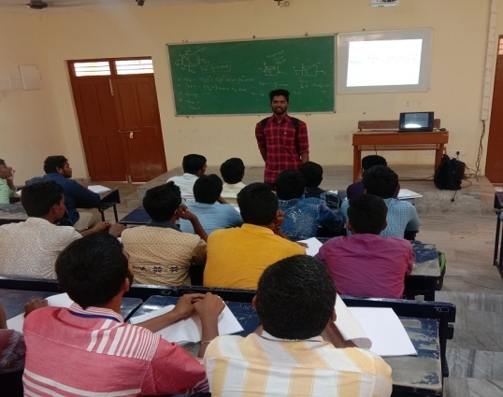

- Mr. Sk Aamir Fahed (14501A0391) who is working in ENGRIN Services Pvt Ltd, Hyderabad interacted with IVB.Tech I Semester S-1students on Careers in Green and Energy, MEP.

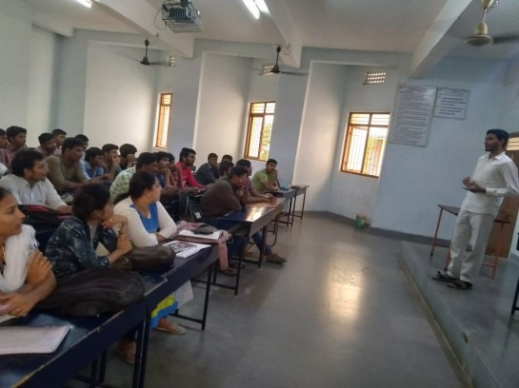

- New Facilities Created:
- 16 number of Turbo fans are installed in Basic Workshop lab.
- Activities of Professional Society:
S.No. | Event Name | Name of the Faculty coordinator | Event date and time | No. of students participated
1 | Technical Paper Presentation | Dr.P.Prashanthi | 13/9/2019  Friday  *3.00pm to 5.00pm | 05
 |  | Sri MVH.Satish Kumar
 |  | Sri T.Srinag
 |  | Sri.G.Bala Krishna
2 | Technical Quiz | Mrs.P.Anusha | 12/9/2019  Thursday  *Screening at 10.00 am  *Final quiz 11.00 am | 86
 |  | Mrs.M.Naga Swapna Sri
3 | Design Contest  (CAD Lab) | Sri. Sd.Abdul Kalam | 11/9/2019  Wednesday  *3.00pm to 5.00pm | 15
 |  | Sri Lakshmikanth
4 | Group Discussion (Metrology Lab) | Mrs.M.Rajya Lakshmi | 12/9/2019  Thursday  *3.00pm to 5.00pm | 11
 |  | Smt KIV.Vandana
5 | Contraption (Heat Transfer Lab) | Mrs. Ch.Vidya | 16/9/2019  Monday  *9 am to 12am | 07
 |  | Mrs.Radha Devi

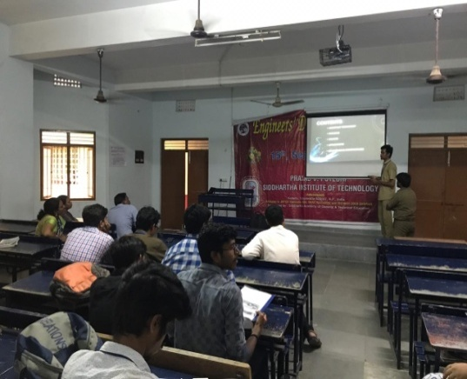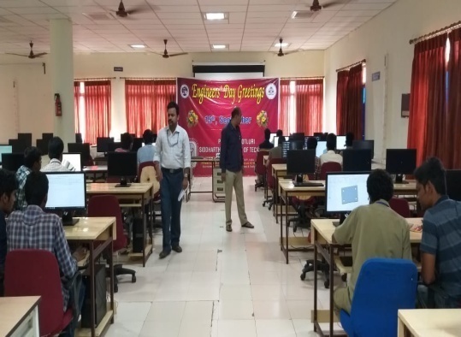
Technical Paper Presentation Design contest

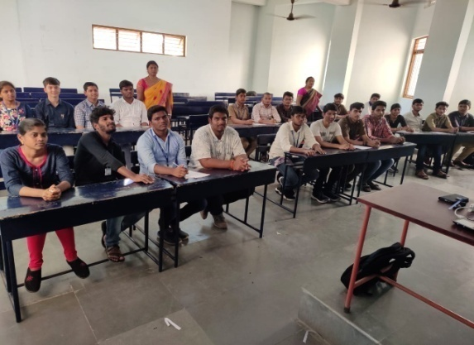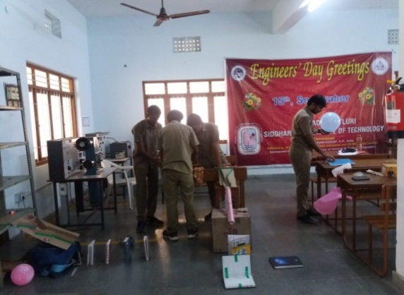
Technical Quiz Contraption

- N.Venkateswara Rao of IV B.Tech. participated in the event, 'Tech Jam' and won the 1st prize conducted by ISTE Student chapter PVPSIT on 9th December, 2019.
- T.T.N.V.Phani Kumar of IV B.Tech. participated in the event, 'Tech Jam' and won the 2nd prize conducted by ISTE Student chapter PVPSIT on 9th December, 2019.
- Sd.Vali Babu of IV B.Tech participated in the event, 'Tech Jam' and won the 3rd prize conducted by ISTE Student chapter PVPSIT on 9th December, 2019.
- J.Sai Revanth,V.Sai Madhav of III B.Tech participated in the event, 'Tech Jam' and won the Consolation prize conducted by ISTE Student chapter PVPSIT on 9th December, 2019.
- M.Phani Priya of II B.Tech participated in the event, 'Tech Jam' and won the Consolation prize conducted by ISTE Student chapter PVPSIT on 9th December, 2019.

- Co-Curricular Activities:

- 26 students participated in Essay writing competition at Gora Science center on 26.07.2019
- Y.Gowtham, P.Anuroop, Y.Pradeep, S.Naga Kumar, and S.Siddhartha of II B.Tech(sec-2) have participated have participated in Automobile & IC Engine Workshop conducted by Kyrion Technologies Pvt Ltd. at IIT Hyderabad on 07th & 08th September,2019.
- G.Chimay Sri, D.Uday Kiran, ASSNV.Vikas, A.Manikanta, A.Abhiram, Noel Prasanth, K.Sai Krishna, and Sai Teja of II B.Tech(sec-1) have participated in Automobile & IC Engine Workshop conducted by Kyrion Technologies Pvt Ltd. at IIT Hyderabad on 21st & 22nd September,2019.
- M.Devi Prasad, M.S.K.Chaitanya, N.Mahesh, R.Madhav, R.Gowtham Sai, S.Koushik, P.Abhishek, S.Pranay, P.Sasidhar, Sk.Kalisha, and Y.Lokesh of II B.Tech (sec-2) have participated in Automobile & IC Engine Workshop conducted by Kyrion Technologies Pvt Ltd. at IIT Hyderabad on 21st & 22nd September, 2019.
- 79 students of B.Tech III Year Mechanical Engineering attended C & DS training classes organized by Dept. of Mechanical Engineering, PVPSIT on 1st November 2019.
- The Department of Mechanical Engineering in collaboration with Future NDT conducted a short-term course for final year Mechanical Engineering students on 6th November, 2019.
- 29 students from IV B.Tech. attended GATE 2020 Training classes scheduled from 18.11.2019.
- P.Anuroop of II B.Tech participated and presented a PPT in WISHV 2K19 a Techno Managerial Fest at NRI Institute of Technology, Guntur on 13th and 14th December, 2019.
- Y.B.Pradeep of II B.Tech participated and presented a PPT in WISHV 2K19 a Techno Managerial Fest at NRI Institute of Technology, Guntur on 13th and 14th December, 2019.
- A.Naga Ravi Teja of III B.Tech acted as a Technical Team Member in organising State Level Koushal Quiz/Poster competition conducted by APCOST and Bharatiya Vijnana Mandali (AP Chapter of Vijnana Bharati) at SRK Institute of Technology, Vijayawada on 14th December, 2019.
- M.Nikhitha,P.Udaya Durga of II B.Tech participated in Power Point Presentation in a Two-Day National Level Techno-Cultural Symposium Dhanush -2K19 at Dhanekula Institute of Engineering & Technology on 20th and 21st December, 2019.
- Md.Salman of III B.Tech participated in Power Point Presentation on “Bamboo Bottle” at a Two-day National Level Techno-Cultural Symposium Dhanush -2K19 at Dhanekula Institute of Engineering & Technology on 20th and 21st December, 2019.
- A.Surya of II B.Tech participated in Automobile & IC Engine Workshop organized by Kyrion Technologies Pvt. Ltd. at IIT Madras Research Park on 28th and 29th December, 2019.
******************

